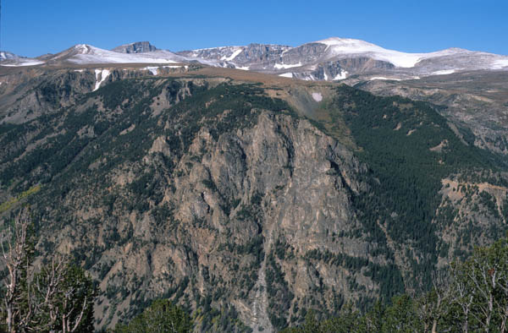

Looking across the Rock Creek drainage to Hellroaring Plateau. Photo by George Wuerthner.

NAME: HELLROARING PLATEAU ADDITION TO AB WILDERNESS

SIZE: 1,941 acres.

ELEVATION: Minimum Elevation 6,731 ft. Maximum Elevation 9,892 ft.

LOCATION: South of Red Lodge, Montana.

FS POLYGON: AB 85.

ATTRIBUTES: The Hellroaring Plateau addition to the AB Wilderness area is adjacent to the Absaroka-Beartooth Wilderness and covers the western slope above Rock Creek by Red Lodge.. The area features steep slopes and cliffs along the west side of the Hell Roaring Plateau Road #2004. Much of the area is high alpine terrain.

PLANT COMMUNITIES: 35% whitebark pine, 25% lodgepole pine, and the remaining 40% is split among dry grass, sparse vegetation, and transitional forest.

WILDLIFE: ELK, mule deer, mountain goat, black bear, and moose.

DRAINAGES IN THE PROPOSED WILDERNESS: Lake Fork, Wyoming Creek.

